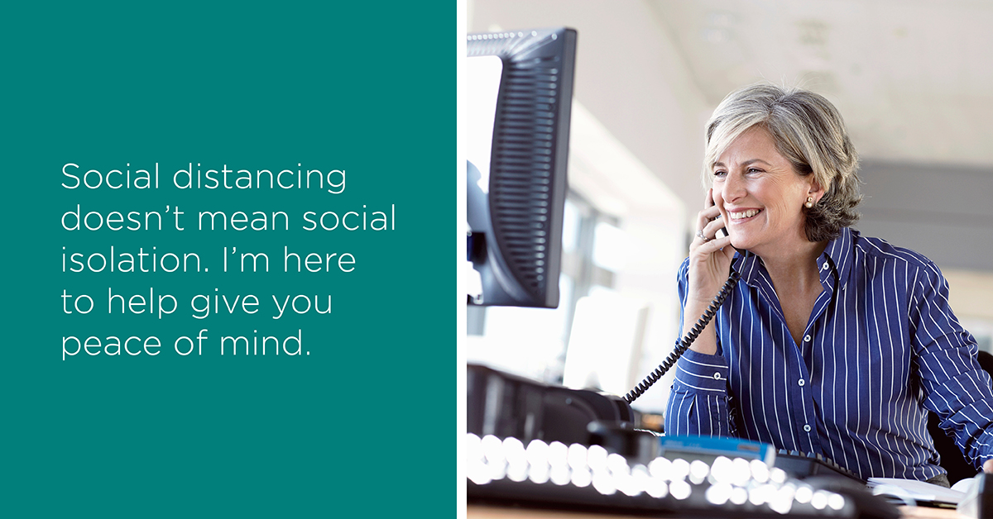

Social Post #1:
Social distancing doesn’t mean social isolation. Connecting with friends, checking in with support systems—even ensuring your family is covered financially—all are necessary for our mental health. I’m here to help give you peace of mind. Message me to set up a time to talk.

Social Post #2:
At times like these, we all need support and a sense of certainty. I can help provide that. Send me a message and we’ll set up a time to talk.

Social Post #3:
Whether by message, email, phone or conference call, I’m available to ensure you’re confident with your current life insurance coverage. Contact me today.

